**DBMS Mini Project**

**Restaurant Management System**

**Team Members:**

Sowmesh Sharma H M (PES1UG21CS609)

Shubh Kanodia (PES1UG21CS587)

**Section:** Sem 5, CSE J.

**Output:**

1. HomePage:

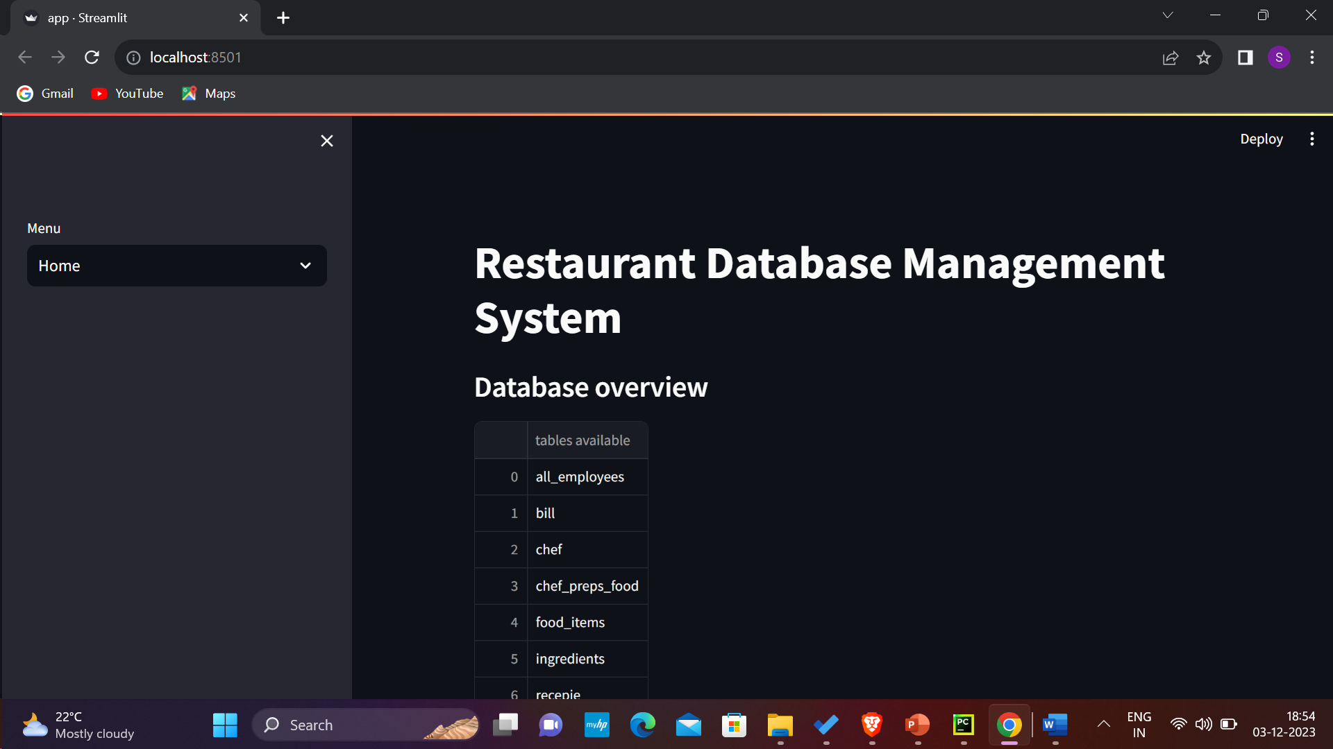

1. View:
2. chef:

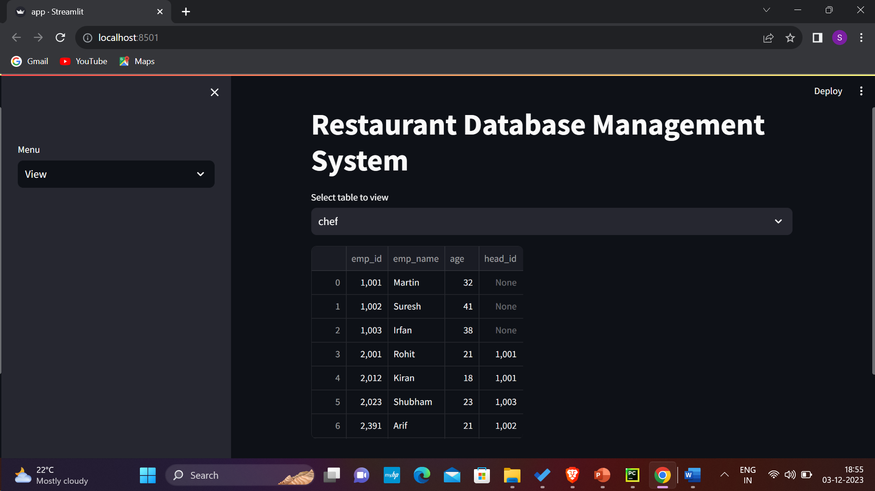

1. food_items:

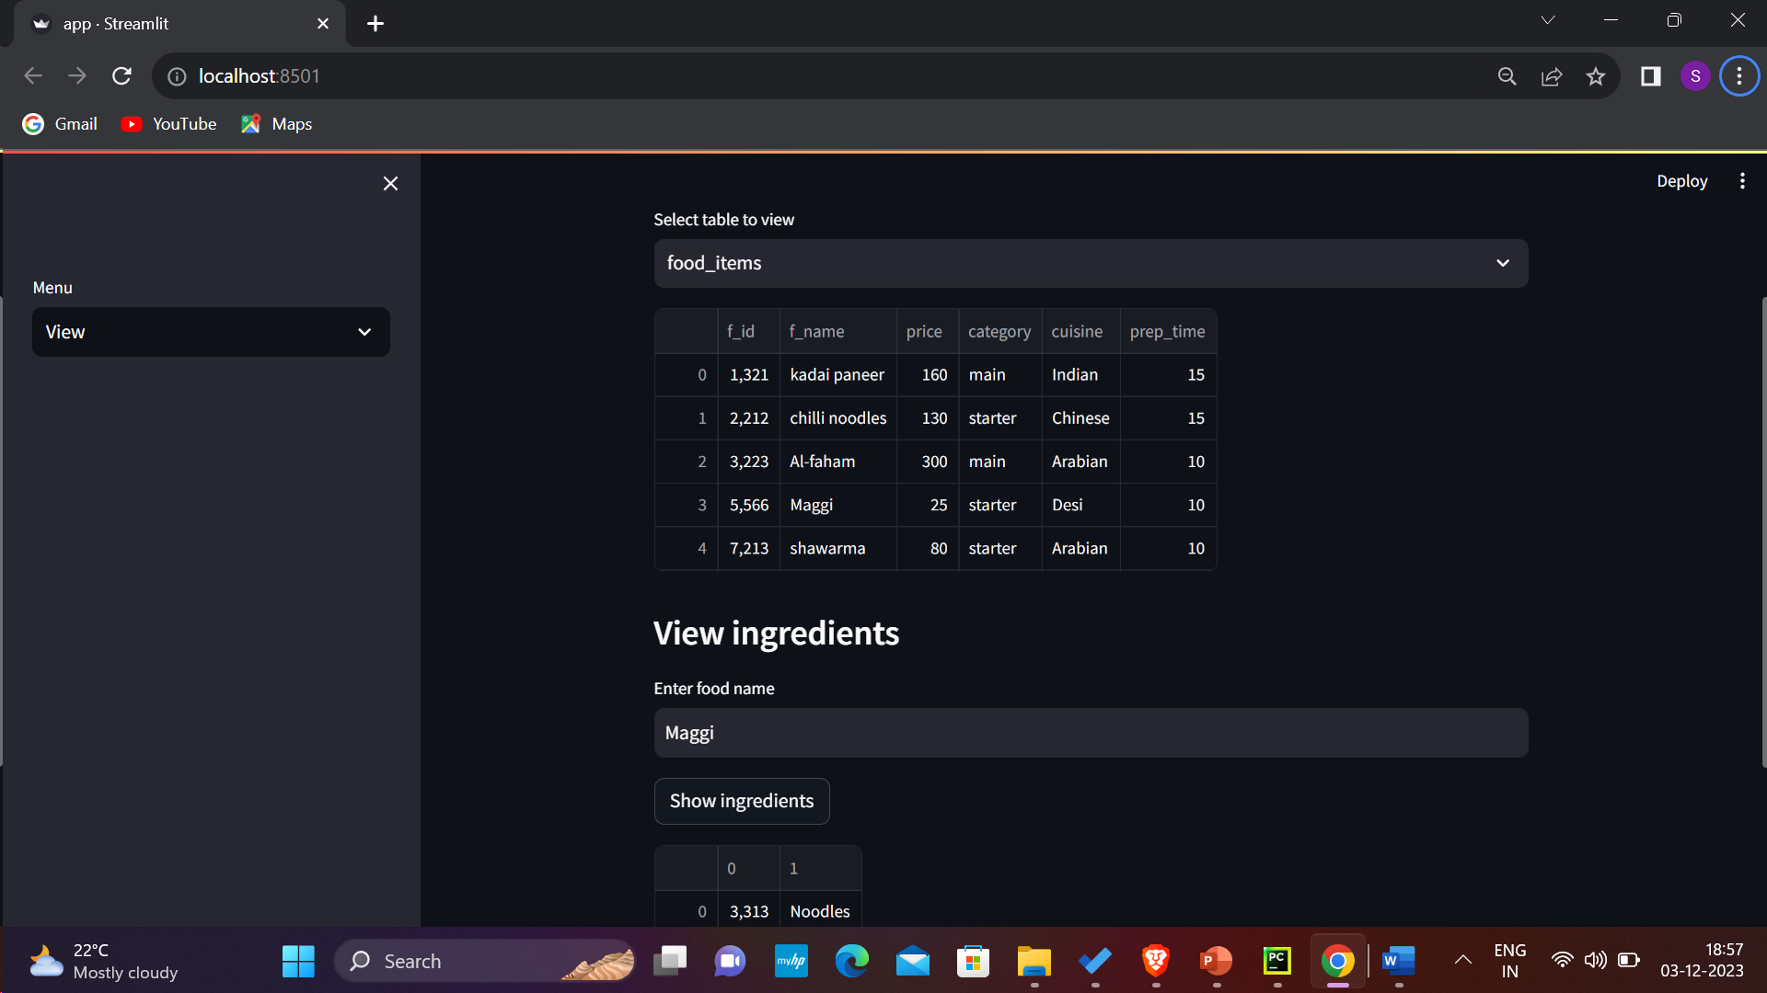

#custom view for food_items table

1. Add:

*add waiter “Joe” with waiter id 255, age=22.

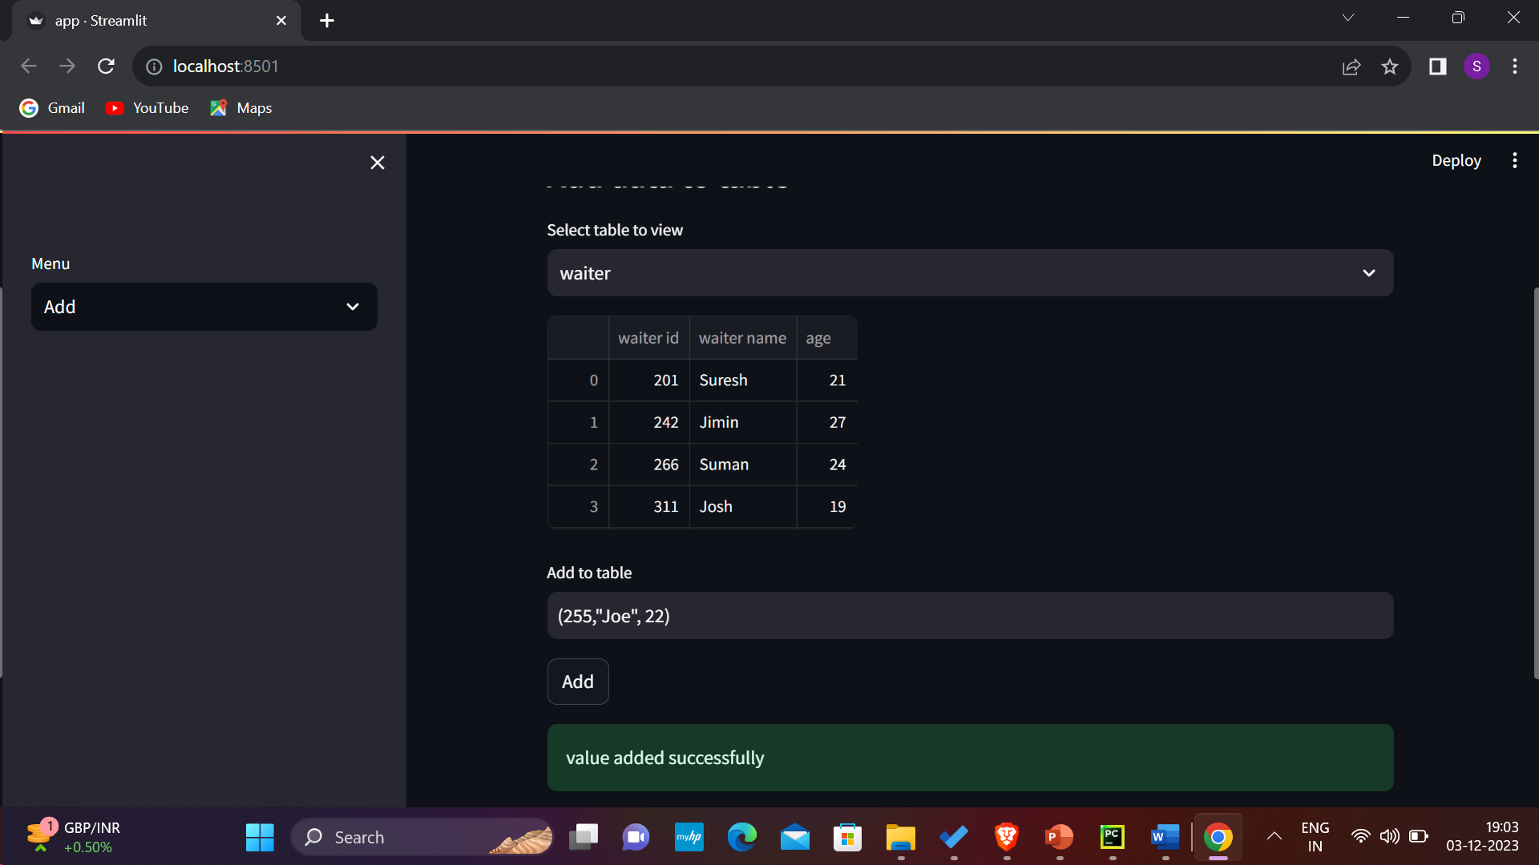

*Reflected table:

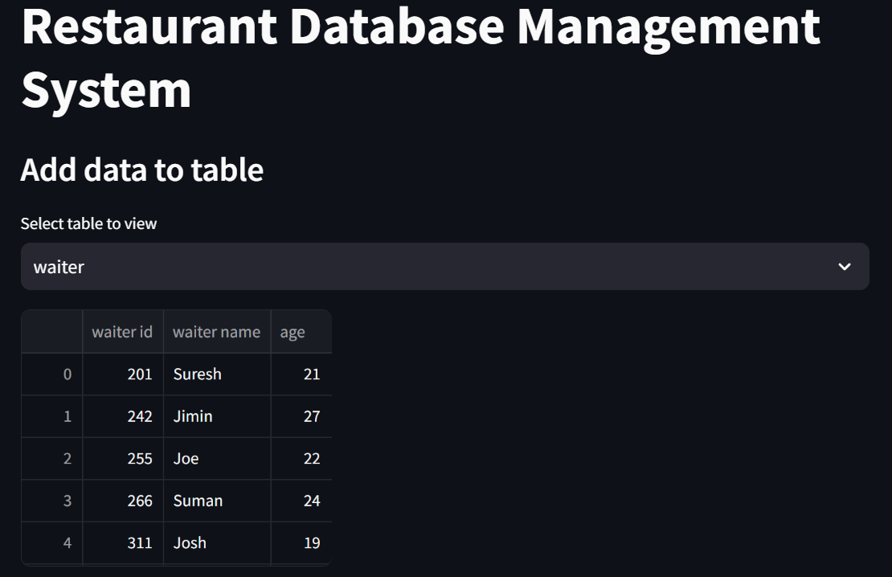

1. Place order:

*Screen:

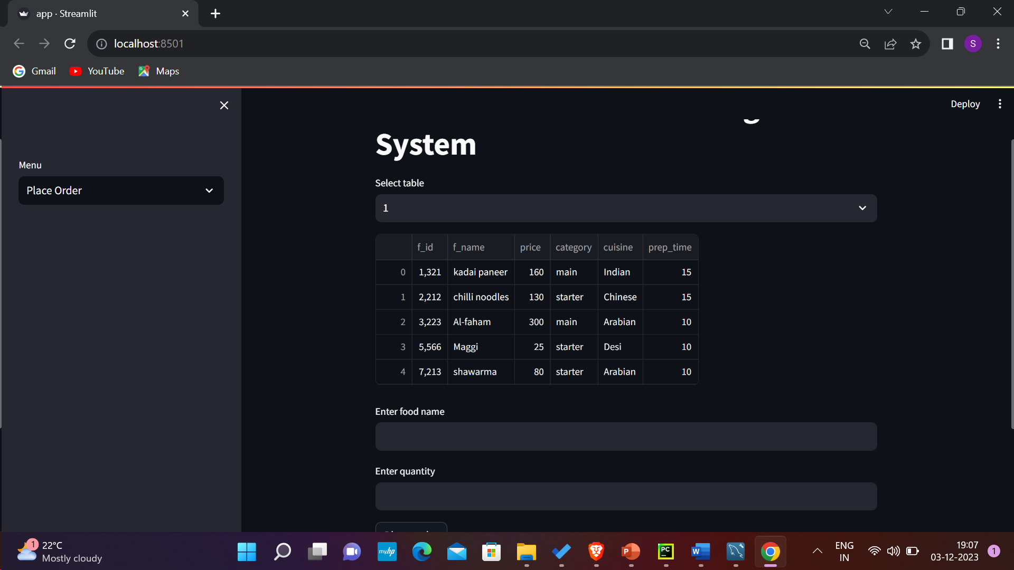

*placing the order on table 6 for kadai paneer:

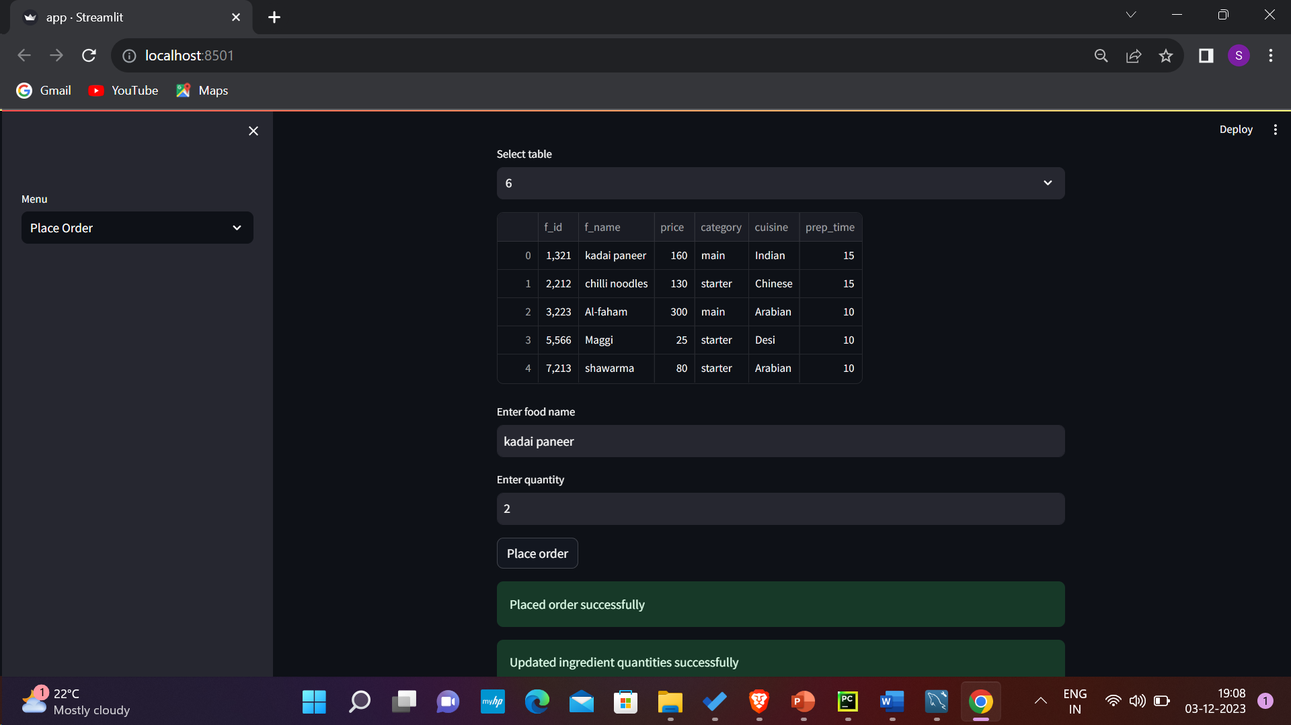

#ingredients table have been updated successfully using a procedure(in which we use a cursor);

Also the table is now reserved and can be billed. (reserved=1). This is done using a trigger.

1. Generate bill:

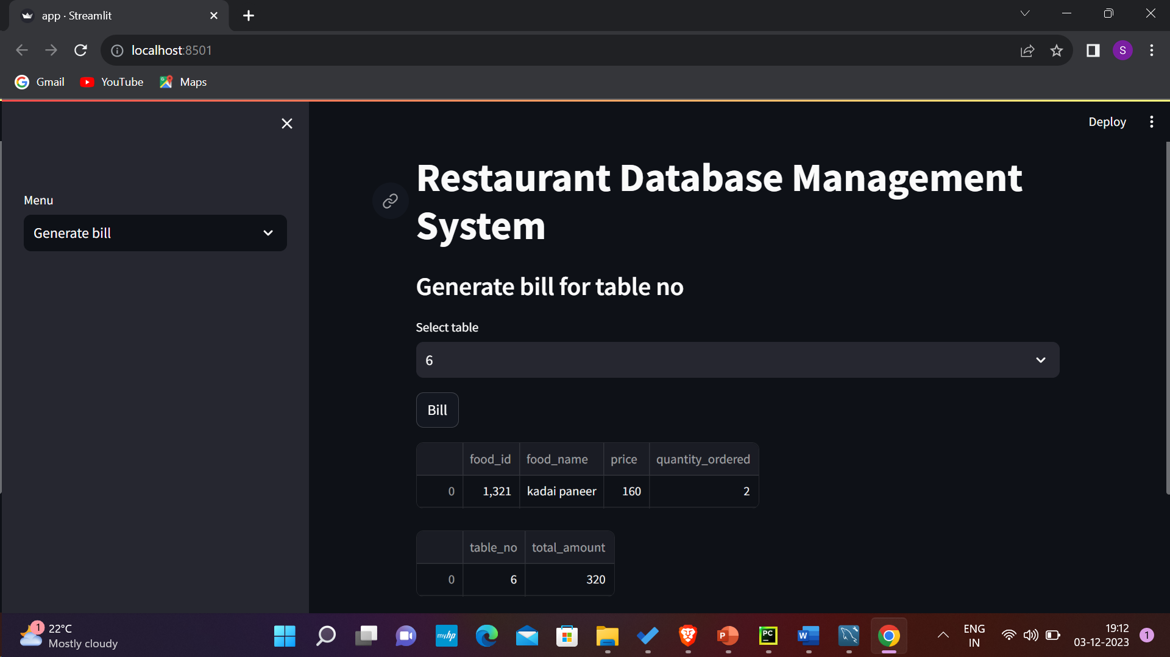

1. View All employees:

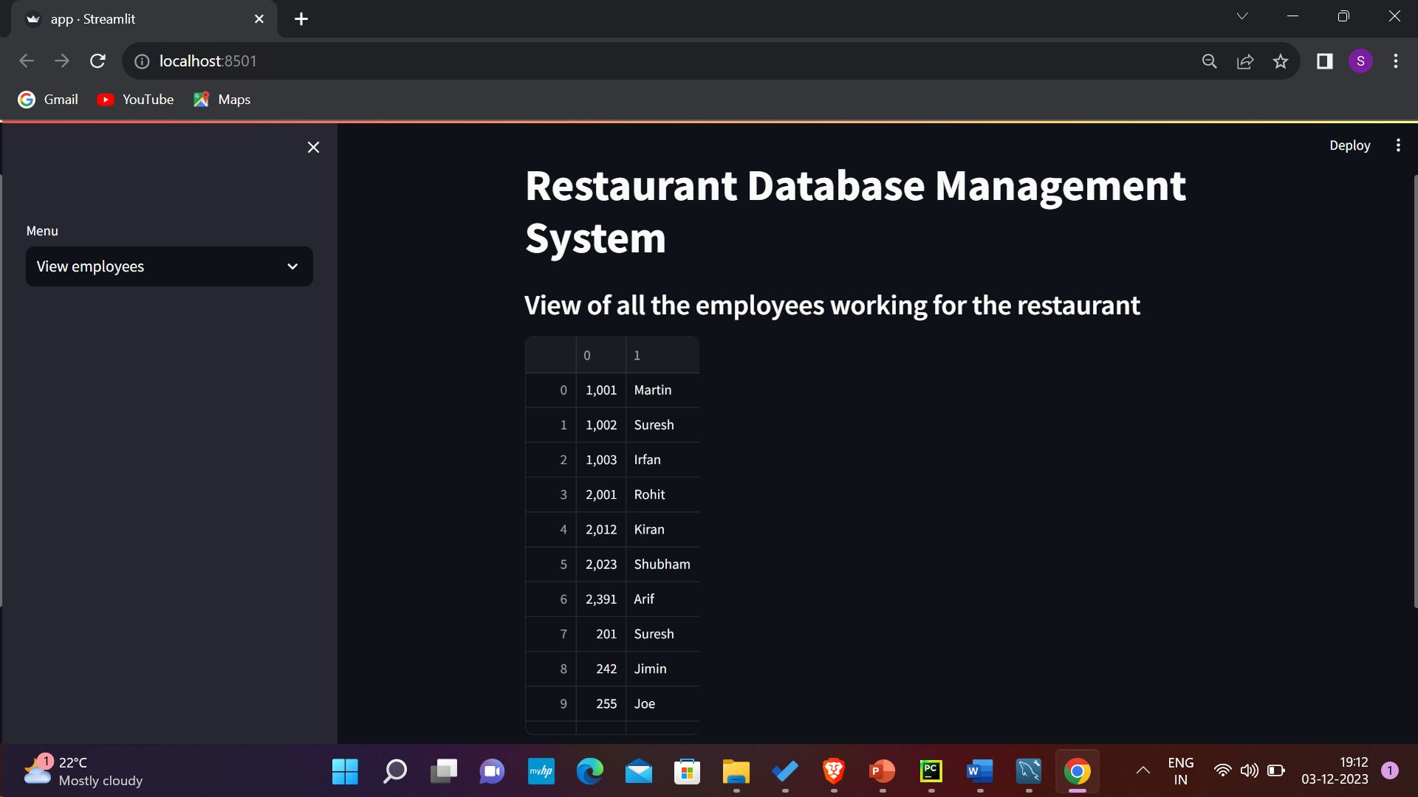

1. Remove employees:

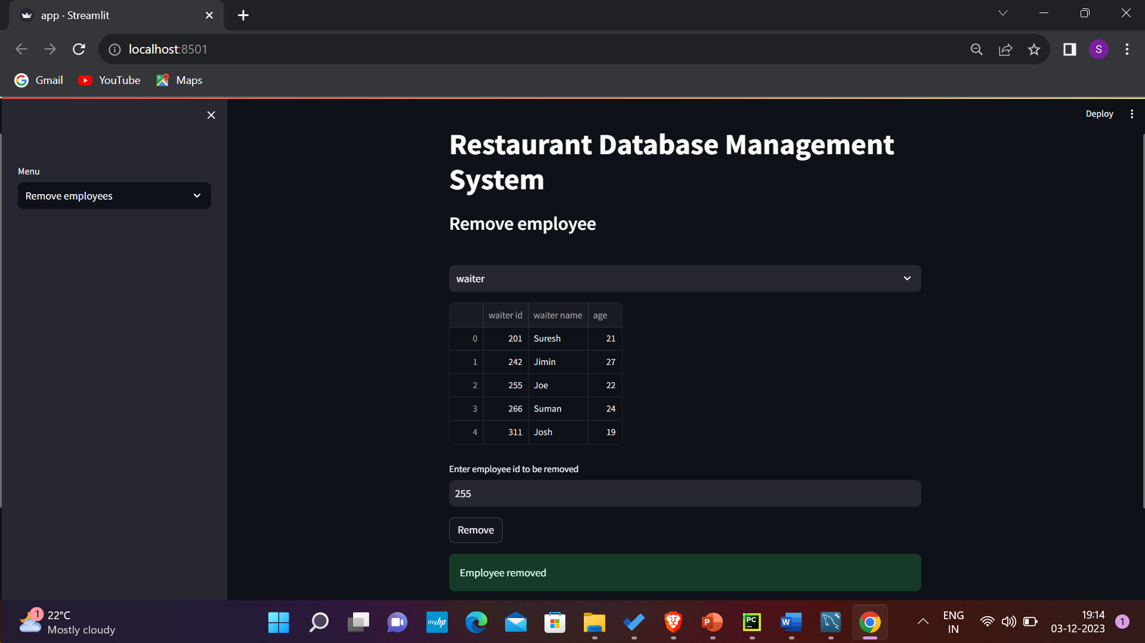

1. Custom Query Engine with UI:

To count the number of ingredients required for each dish : dish_id vs no_ingr:

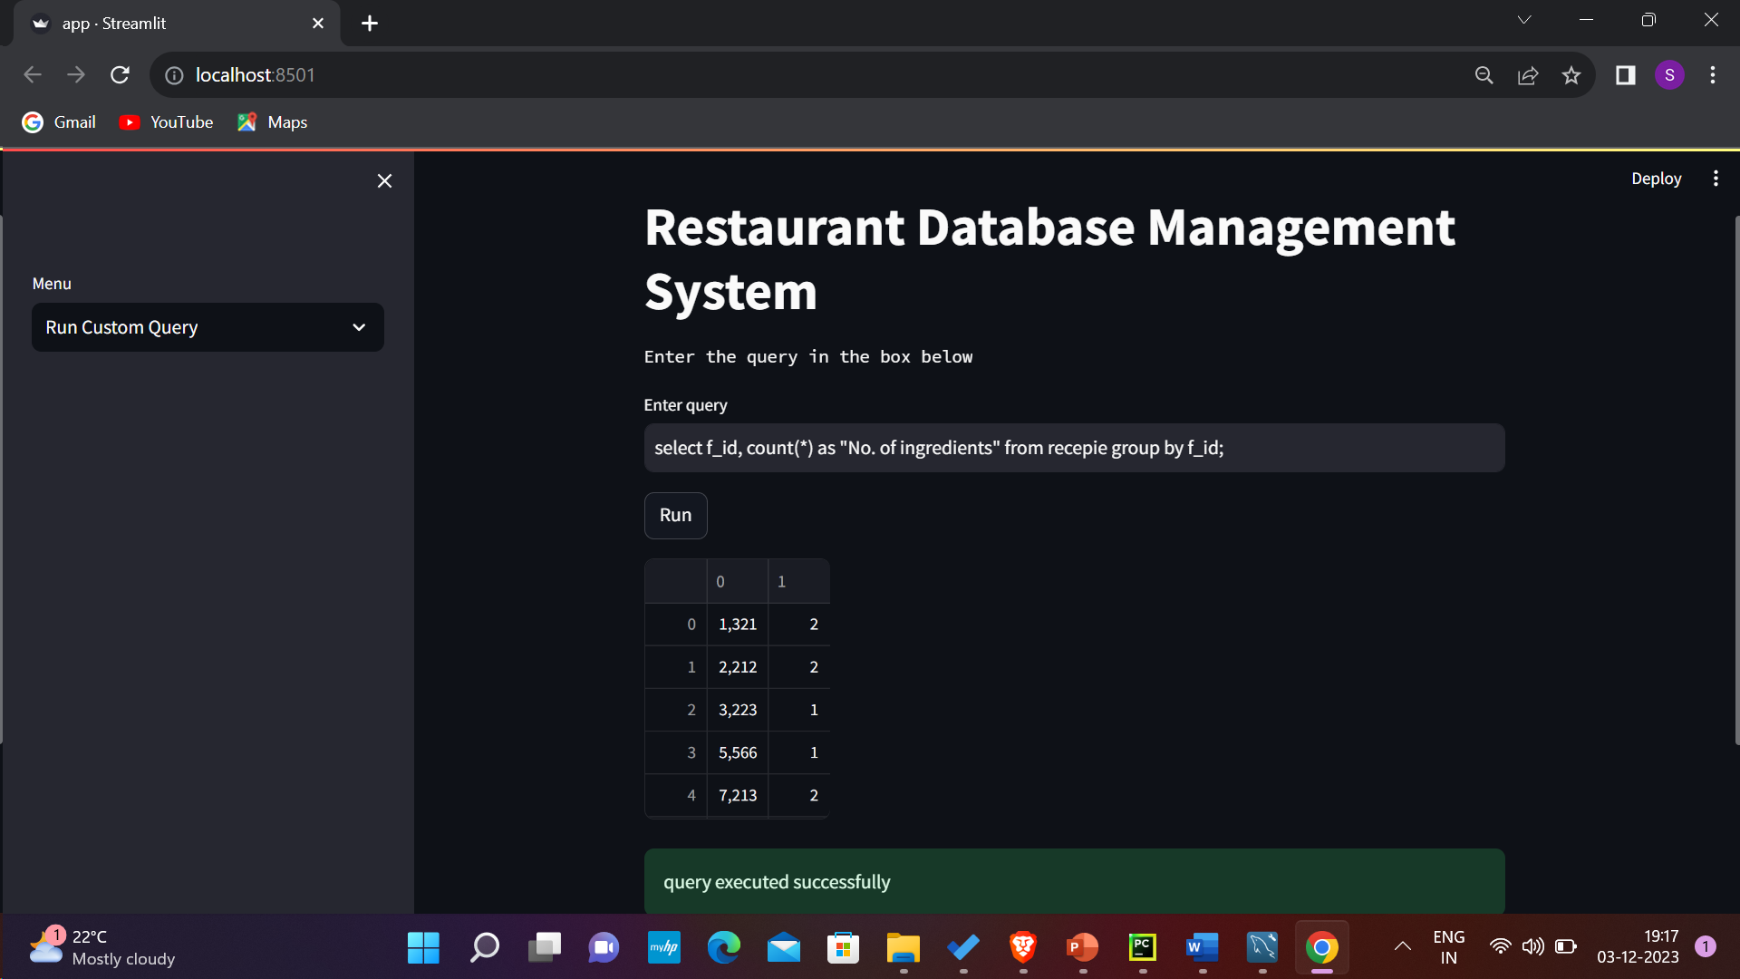

**Key Takeaways from project:**  
This project was very fruitful for us as we learnt various aspects of mysql, how multiple CRUD operations work in a database along with functions and triggers and how the knowledge of these concepts can be leveraged to build an end-to-end restaurant management system, it also taught us how the ACID properties are relevant when we are building a real world project like this, moreover we also learnt how to connect mysql to python and build a user interface using Streamlit.